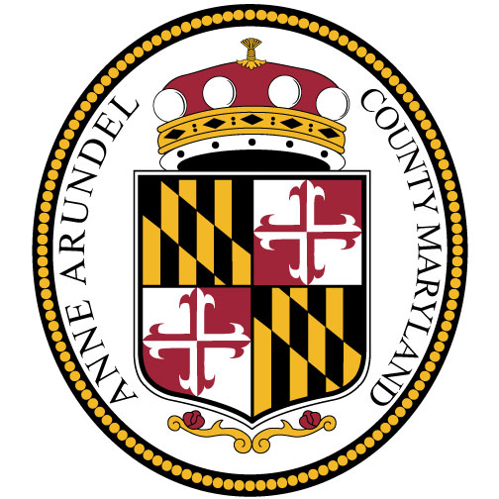
CUSTOMER RESOURCES

- Anne Arundel County Department of Aging and Disabilities

Older adults, people with disabilities and caregivers may call to access resources for: caregiving assistance, transportation resources, financial assistance, housing, nutrition, and more.
Monday-Friday, 8:00AM-4:30PM, 410-222-4257
www.aacounty.org/aging

- Anne Arundel County Department of Social Services

Temporary Cash Assistance, Supplemental Nutrition Assistance Program (SNAP) a.k.a Food Stamps, Apply online for assistance at: https://mydhrbenefits.dhr.state.md.us/, or by calling 1-800-332-6347.

Emergency Assistance to Adults may provide assistance for the following:
• Court-Ordered Eviction • Utility Cut-off • Life Sustaining Medications • Shelter Referrals • Referrals for furniture, food, clothing • Referrals for services to address Domestic Violence

Annapolis Glen Burnie
80 West Street 7500 Ritchie Hwy
Annapolis, MD 21401 Glen Burnie, MD 21060
410-269-4500 410-269-4500
Email: aacountydss.dhr@maryland.gov

- Anne Arundel County Partnership for Children, Youth, and Families

Offering individualized support connecting Children, Youth, and Families to critical services to address not only day to day challenges, but those posed by the pandemic. Call the Information and Referral line to learn about resources including: mental health services, food, housing, utilities, crisis or emergency services, mentoring, parent training and education, eligibility screening for benefits and much, much more.
1-800-485-0041
https://www.aacounty.org/boards-and-commissions/partnership-for-children-youth-families/index.html

- Eviction Prevention, Foreclosure Prevention, Homeownership Counseling, and Property Rehabilitation - Arundel Community Development Services, Inc.

At this time, ACDS and our community partners are faced with managing limited funding and are closing the waiting list to new intakes. Effective February 22, 2022, funding will be prioritized for households already on the waiting list or households who have received a Sheriff’s notification to evict. All financial assistance is contingent upon funds being available at the time a household’s application is processed. Unfortunately, funding for payment of past due rent is not guaranteed, and applicants already on the waiting list are encouraged to pay their rent, if possible, and to look for other resources while waiting for their application to be processed.
410-222-7600
https://acdsinc.org/
https://acdsinc.org/housing-resources/renters/acds-eviction-prevention-program/

- Water Bill Assistance

Low-income homeowners in need of assistance can check eligibility for the Low Income Household Water Assistance Program through the County’s Department of Social Services/Maryland Department of Human Resources by clicking HERE Low Income Household Water Assistance Program - Maryland Department of Human Services

- Energy Assistance Program - Community Action Agency

This program is targeted to customers who do not qualify for the Maryland Energy Assistance Program and other electric and utility programs.

Please call the Community Action Agency's 24/7 hotline at 833-888-0401

- Supportive Services for Anne Arundel County Residents- Arundel Workforce Development Corporation

Provides support for job seekers and businesses.
410-424-3240
www.aawdc.org

- Serving People Across Neighborhoods (SPAN)

SPAN assists neighbors in need with utility turn-offs, court-ordered evictions, prescriptions/medical costs and food. For more information about their program, please call 410-647-0889, Monday - Thursday 10am - 1:45pm

400 Benfield Rd
Severna Park, MD
https://www.spanhelps.org

- NCEON (NORTH COUNTY EMERGENCY OUTREACH NETWORK)

NCEON is open for financial, prescription and food assistance on Monday, Wednesday and Friday from 10:00 AM to 1:30 PM. Financial assistance will be in support of Utility turn off notices, court ordered Evictions and Prescriptions. Utility notices, Evictions and Prescriptions must be in the client’s name. Appointments are required for financial assistance, please call 410-766-1826, during business hours to set-up an appointment.

304 5th Avenue SE
Glen Burnie, MD 21061
https://olchesapeake.org/nceon

- St. Vincent DePaul Society

St. Vincent DePaul Society provides a food pantry and limited financial help with utilities (cut off notice required), prevention of eviction (must have been to court and have notice signed by judge), and prescriptions. You can reach them at 443-261-0109 during our volunteer hours, Tuesdays and Fridays from 10a.m.—1p.m.

689 Ritchie Highway
Severna Park, MD 21146
https://stjohnsp.org

- Transportation

- Anne Arundel County Office of Transportation
410-222-7440
www.aacounty.org/transportation

- Taxi Voucher Program - Department of Aging and Disabilities
Serving older adults (55+) and individuals with disabilities
410-222-4CAB (4222)
www.aacounty.org/aging

- City of Annapolis
410-263-7964
https://www.annapolis.gov/159/Transportation

- COVID-19 Health Line - Anne Arundel County Department of Health

For information on COVID health, vaccine and testing sites, call the COVID Warm Line,
Monday-Friday 8AM-4PM, Saturday 10AM-2PM, 410-222-7256
Email: covid19info@aacounty.org
www.aahealth.org

- Crisis Warmline - Anne Arundel County Mental Health

The Crisis Response System known as the "Community Warmline" is a service that provides Anne Arundel County Residents in crisis with supportive assistance and linkages to resources within the community.

For more information about this program, please call (410) 768-5522, 24 hours a day, 7 days a week.

For all resources, TTY users please call via Maryland Relay 7-1-1

